Greenbone Community Edition

The first thing you need to do is download the iso file from

<https://www.greenbone.net/en/community-edition/> from the “Download Now section”

Next we need to set up a virtualbox for it.

Click the new button then name it and select the options below

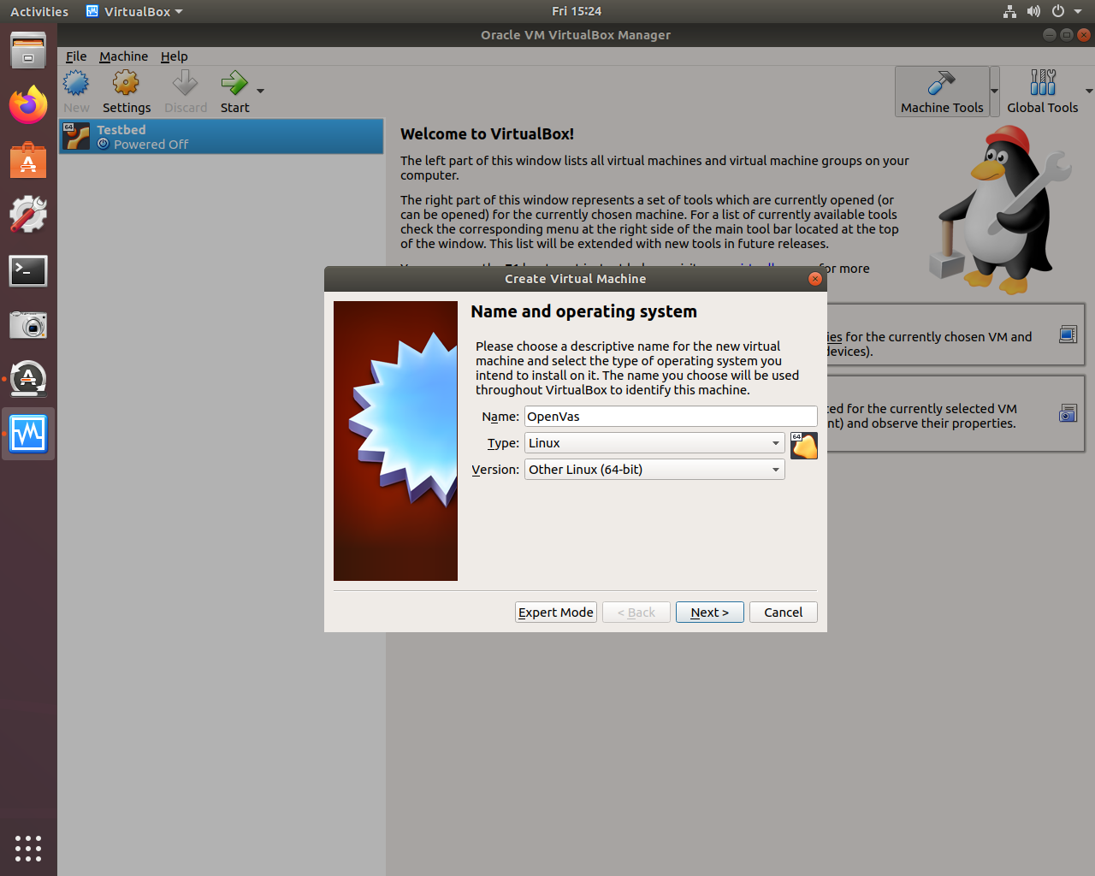

Next select the Ram size for the virtualbox 8gb is recomended

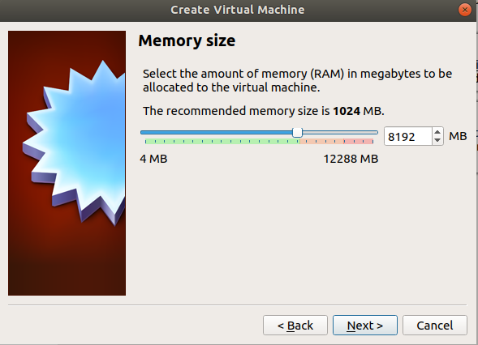

On the next option select create virtual hardisk now 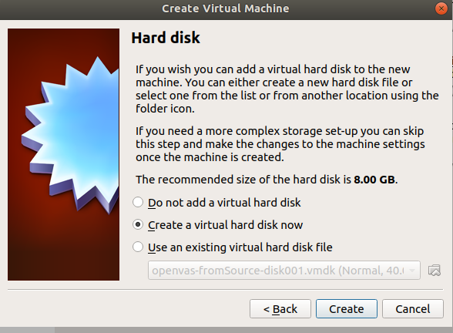

Select VDI

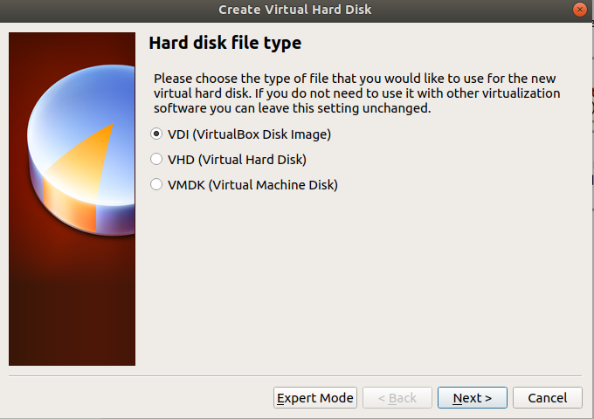

Now select Fixed size

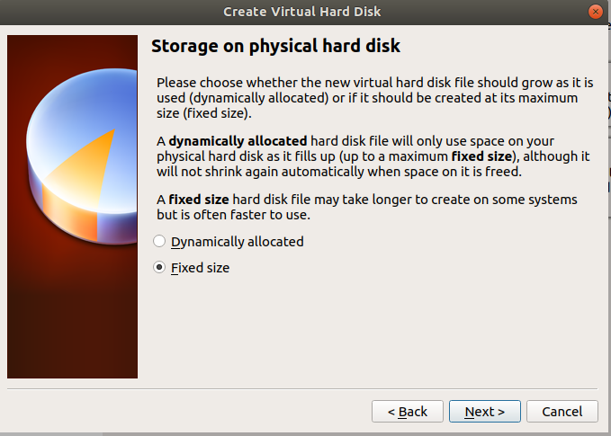

Give it 40 GB

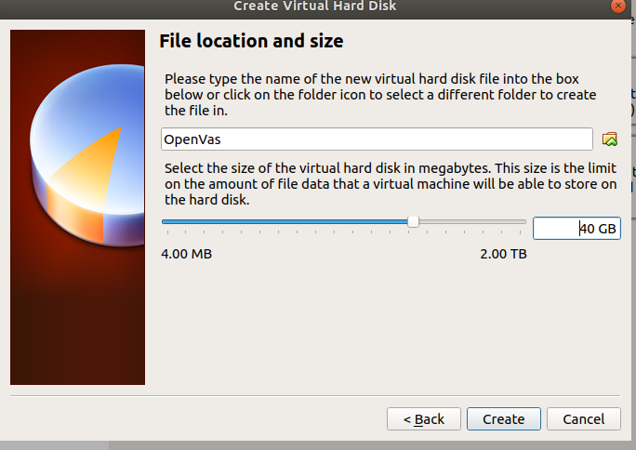

Click the start button and on the startup disk option choose the iso you downloaded

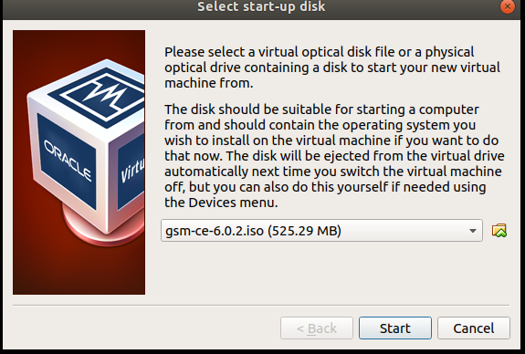

Wait for it to startup then choose start setup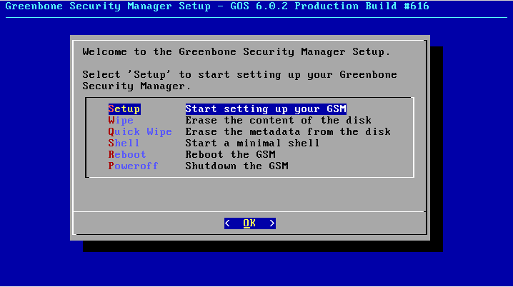

Choose Yes on the first screen

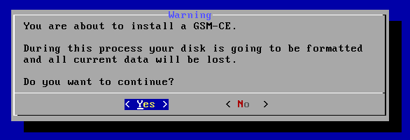

You will get this screen just wait for it to be done

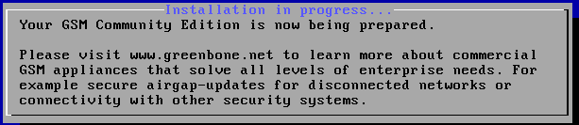

It will ask you what to name the admin for this test we just went admin

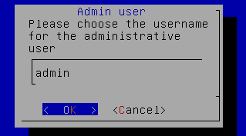

And now a password

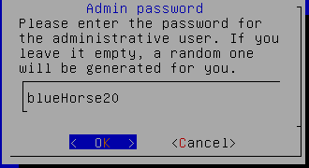

It will then ask you to reboot Select yes 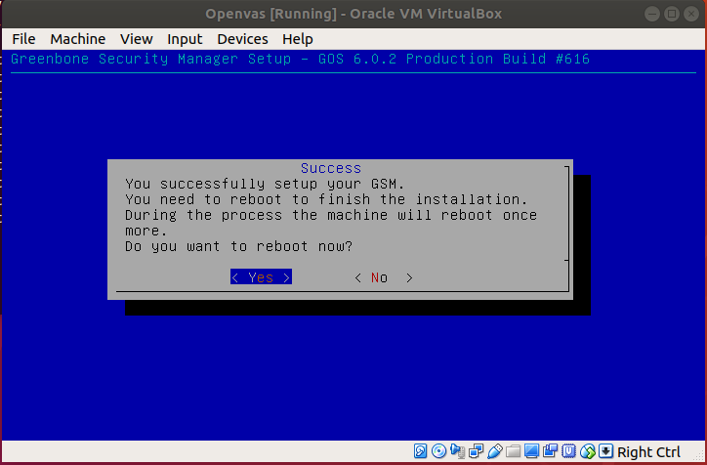

You also want to eject the disc

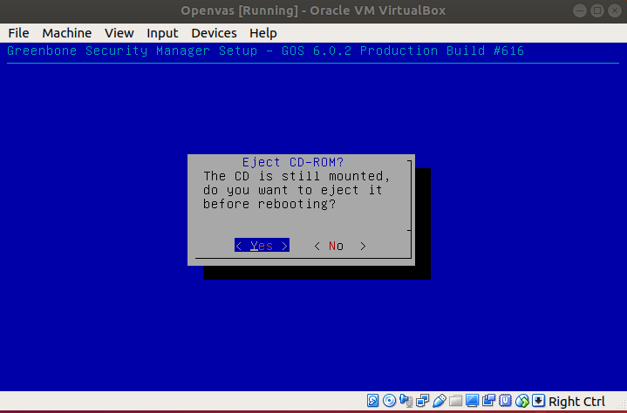

It will reboot follow its instructions and dont log in until it reboots again

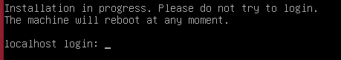

Once you log in it will ask you to complete setup select yes

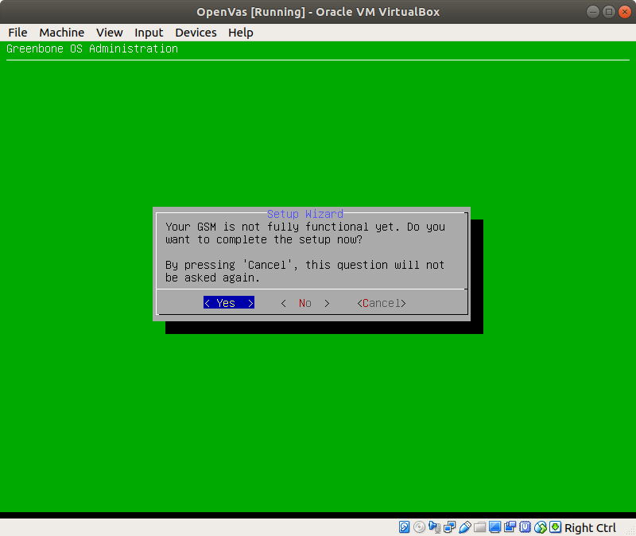

It will then ask you to create a web admin select yes

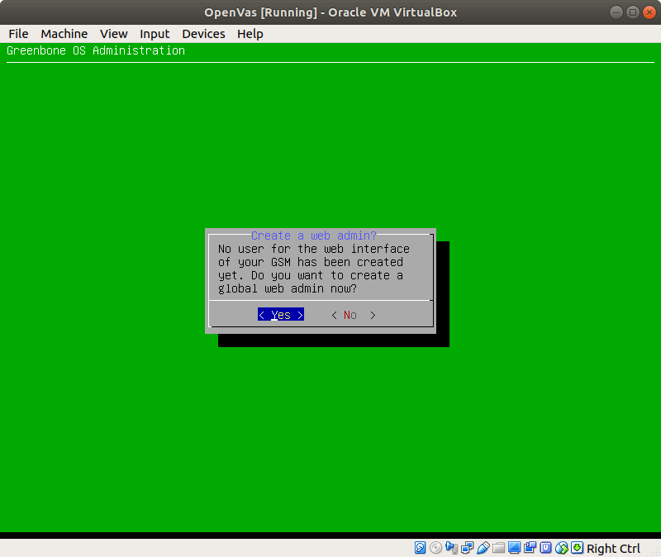

Skip the security key

